**Entry Registration Number:**

# 15S

You may leave this blank if you are submitting your Project Details File online as electronic copy.

**1. Title of the Invention**

**ORB-The world’s first 3D gaming mouse**

**2. Brief Description of the Invention**

Briefly describe your invention

Give a brief description of your invention: What is the invention for? What is it made of? How does it work? Etc.

*(*Please try not to exceed 200 words)*

**What is ORB?**

**Orb is a must have peripheral device in every household. It is the world’s first**

**gaming oriented 3-Dimentional mouse that you can drag, twist and manipulate in thin Air. This allows the Orb to be used in almost all environments ~~P~~possible, making your life much easier with the Orb. Many have the misconception that the only people manipulating 3D ~~E~~environments on a screen are 3D Modellers thus the release of several Modeller oriented 3D mice. Gamers are much often left out but that is all about to be changed. Meet the Orb — The Biggest Game Changer Yet!**

**How does ORB work?**

**Orb works on a simple system that consists of accelerometers and gyroscopes forming what is known as a Inertial Measurement Unit (IMU). This IMU is able to detect slight movements in 6 ~~D~~degrees of ~~Ff~~reedom. This enables the ~~G~~gamer to easily manipulate the 3D environment using a flick of the ~~W~~wrist. This, combined with some intelligent programming, would allow us to translate the IMU data into movement ~~C~~commands for the cursor and also key presses for the keyboard. This combined with the circular case design for the Orb as shown in Figure 1.1 makes it extremely easy to hold in the hand and use.**

**Future improvements for ORB**

**The Orb at this stage is just a prototype and ~~there~~ we will be many improvements to it. ~~in time to come~~. Adding wireless connectivity using 2.4GH~~h~~z wireless communication to allow the Orb to be used for presentations and having a more ergonomic case designs will be one of the few design improvements that will be implemented. Fine-tuning of the programming and adding several more features for the user’s comfort and ease of use will also be done. Overall, we will try our best to make it the best ~~polished~~ product it can be.**

Photograph(s) or drawing(s) of your invention prototype

Please supply at least one photograph or drawing of your invention prototype. Show the internal structure of the invention by illustration, if necessary

*(*Actual invention/prototype is required for presentation during the interview if the invention is short-listed.)*

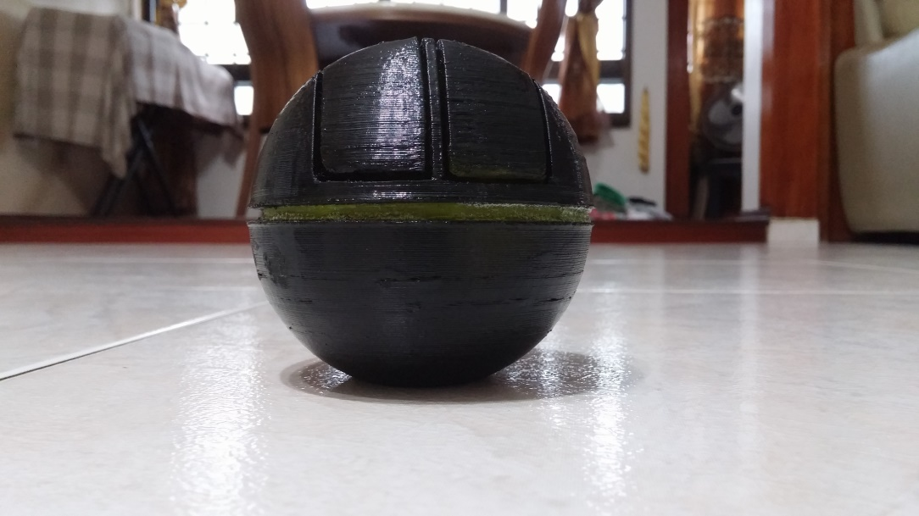

Figure 1- Current Case Mockup of the Orb

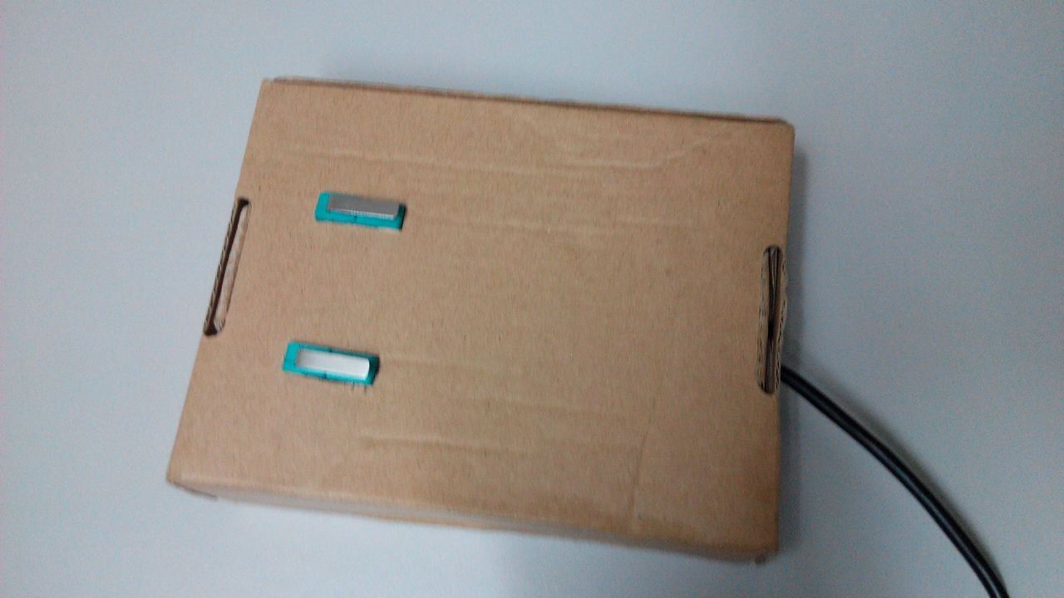

Figure 2- First Prototype Case of Orb ~~circuit~~ bo

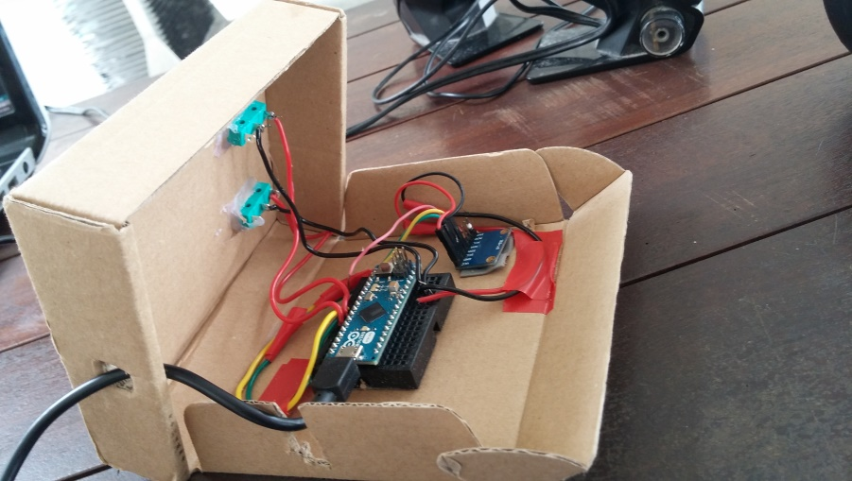

IMU to measure motion in 6DOF

Left and Right click buttons

Arduino Micro to process data

Figure 3 – Electrical Components inside Orb

**3. Detailed explanation of the Invention**

Describe the novelty or originality of your invention

List the outstanding characteristics of your invention

**Orb is the one and only 3D mouse in the world right now that is completely oriented at gamers. It uses common technologies to provide a new face to gaming and allows a whole new level of immersion. This product can be used in conjunction with technologies like the Oculus Rift to provide full immersion. It also has the function of using either 2D or 3D mode allowing users to choose the way they want to play. Thus, Orb can function in the air allowing users to game on the go, either on the bus or the train. Orb can be used as a normal mouse, a 3D mouse and as a joystick allowing the Orb to have many uses which normal mice could never have.**

**Current designs of 3D mice though stylish, are big bulky and non-desirable for gamers especially who need speed and ease of movement to game competitively. Ease of use, more immersion, portable gaming, multi-use and the ability to be compact clearly define Orb and set us far apart from existing designs making Orb extremely novel.**

Are there existing or alternative products?

What sets your invention apart from previous creations, in terms of its feature, its method or its functionality?

**Logitech’s Gyration (air mouse is one of the few products similar to Orb, but it is not a 3D mouse. Logitech’s Gyration is ~~but~~ an Inertial mouse. An inertial mouse is a mouse that using a Inertial Measurement unit (IMU) which is also what Orb is using. However, Logitech’s Gyration does not have the 6 axis of freedom that Orb has. Logitech’s Gyration has only ~~has~~ 2 axis of freedom. This is mainly because of the difficulties in programming that result from giving it 6 axes and there would be too much random noise in the reading. However, we have implemented a programming solution to that problem.**

**~~It~~ Logitech’s Gyration is also NOT geared towards gamers, does not have the ability to switch between 2D and 3D modes, has no multi-uses, and is overall a presentation style mouse. This also applies to other inertial mice which are scarcely spread across the mouse market. Therefore, I believe there is no alternative product that can effectively fulfil the role of Orb without having some forms of disadvantages to the gamer.**

Other points or aspects that you would like to highlight, if any.

**4. Practical Applications and Usefulness of the Invention**

Who would the user be?

**~~As mentioned several times throughout this report,~~ Orb is a 3D gaming mouse and the target audience would typically be gamers. However, this 3D mouse also offers some promises for 3D designers and Modelers as these modelers could also use our mouse on the go for 3D designing. Current 3D mi~~s~~ce designed for modelers are bulky and relatively large thus making our small and compact design a huge selling point. 3D modelers will want the compactness and ease of use of the Orb so that they can design on the go.**

Why would potential users want to use your invention?

**Gamers will want to use the Orb as ~~the main point of Orb is to open~~ a whole new way of playing 3D games. Its ability to immerse the gamer in the game and to use the gamer’s natural reflexes to move the control will allow the gamer to have precise control over his/her character and this itself is a huge selling point.**

**In addition, ~~Not to mention,~~ ~~the~~ Orb is a fully portable and compact system allowing the gamer to easily bring it with her on long trips and game on without any hassle about whether there is a surface for the mouse. 3D modelers would likely also want it for this feature of portability and that makes these potential users want to use our invention.**

**5. Additional Information about the Invention**

Have you got any patent right for your invention?

If yes, please provide the name of Principal inventor and number of inventors listed in your patent document.

**No.**

Did you receive assistance in the development of this invention?

If yes, please describe the nature & extent of assistance received.

**My teacher has assisted us in getting materials for the building of our prototype and fully supported us throughout the course of this project. However, the theory of operation, schematic and circuit design and software programming was completely done by us along with all other hardware and software related developments.**

Has your invention been submitted to any other competition or won any award?

If yes, please provide details.

**No.**

Write a short description of your experience as an inventor.

*(*Optional)*

**We had a truly enriching experience with inventing something. We had to face several problems along the way with the most prominent problem being finding a problem to solve in the first place. From finding a problem to solve, to going through several design and prototyping stages it was overall a very enlightening experience which we will say was very useful to us.**

**6. Endorsement by Proper Authority**

*(* applicable to those applying through schools, institutes or companies, etc)*

This submission has been endorsed by:

|  |  |
| --- | --- |
| Name: | Pek Peng Kiat |
|  |  |
| Designation: | Assistant Head, Design & Engineering |
|  |  |
| Organization: | NUS High School of Math & Science |
|  |  |
| Address: | 20 Clementi Ave 1, Singapore 129957 |
|  |  |
| Contact No.: | 6516 5310 |

**Appendix**

**7. Other supporting materials (*Optional)**

Trials, papers, literature or correspondence, which might assist the judges in evaluating your idea

*(*Please insert a new page if space is not sufficient)*